**Coda Global Full-Stack Developer Challenge**

[yamini10.thota@gmail.com]

11

:

31

:

07

left

[Finish Test](https://www.hackerearth.com/coda-global-full-stack-developer-challenge/problems/ae286b3713f5442dba23af423f82de22/)

**1** questions Max. Marks: **100.0**

**1 File Upload Questions**

1.

LearnHub — a simplified courses search portal!

Max. Marks: 100.0

.

LearnHub — a simplified courses search portal!

**[Problem Statement]**

Develop a web application which would let users search and list courses conveniently.

**[Minimum Requirement]**

— Use of Data dump (available in CSV/MySQL) for **courses detail**:

* Data Parameters: **courses[] —> { id, title, price, type, category, description, rating, image, url}**
  + **title** AS text (course name)
  + **price** AS text (price format: Rs. ? INR / month).
  + **type** AS text (Beginner, Intermediate, Advanced)
  + **category** AS text (Technological Stack)
  + **description** AS text (contextual description of course)
  + **rating** AS float (rating of the course; on 0-5 scale)
  + **image** AS text (image of the course; contains URL or base64 image)
  + **url** AS text (url of course)
* ^ Some parameters may have twist in it; handle it gracefully!

— Parse data dump to your favourite data format.

* You are free to use any method to store dataset.
* i.e.: MySQL, NoSQL, Solr or Elastic Search.

— **Minimal** back-end developed (to interact with database and handle misc. feature) in your favourite backend language; **(i.e. Python, PHP or Java)**.

— Emphasis on **functional design listing course** details. (focus on UI/design part)

**— Submit Screenshot, Source code & Instructions to deploy webapp.**

**[Plus Point]**

— Implement **Search** (by title) feature.

— Perform UI tweaks to design front-end layout and URL link with target="_blank". [display Total Courses (count), Rating, Paging ]

— Documented, well structured beautified code.

— Awesome if you could manage to **host** this application somewhere with **Demo URL**! (Heroku, AWS, rackspace or OpenShift)

**[Extra Work]** (if time permits)

— Implement **Sort** (by Rating or Price) feature.

— Code a **category** feature (to filter Courses by particular category).

— Documentation (sample):

* Plus if you can manage to add documentation containing insightful details on project flow / technological stack used.
* A document explaining the current status and proposed enhancements for the web app.

— Utilise client-side scripting and UI functionality; Custom design, font and icons to make web-app more user-friendly.

— Use your imagination and add features which would make feature rich web app; we always admire creative coding.

— You may add portfolio comprising awesome work you have done on Java/Web applications.

**[Guide]**

**— Course Data Chunk:**

* MySQL: [http://hackerearth.0x10.info/dump/LearnHub.sql](http://goo.gl/5QC7Vw)
* CSV: [http://hackerearth.0x10.info/dump/LearnHub.csv](http://goo.gl/Mo4Xxv)

— Given mockup design is just for reference, you may come up with your own design and layout; keep it minimal and simple and emphasis on overall UI/UX.

— You are free to use more robust RESTful URL hierarchy; given structure is to help you kickstart with the development.

**— Ideal Stack:**

* For Backend: Feel free to use Java, PHP or Python (feel free to use any of your favourite framework).
* For front-end UI/UX: Feel free to use any front end layout to simplify user experience (any CSS, JS framework).

— For **query/issue/support**, we are also live on IRC (Freenote network) at [**#hackerearth**](http://webchat.freenode.net/?channels=hackerearth&uio=d4).

— You may use below resources for misc. things:

* <http://subtlepatterns.com/thumbnail-view/>
* <http://getbootstrap.com/components/>
* <https://material.angularjs.org/latest/>
* <http://materializecss.com/>
* <https://www.google.com/fonts>
* <http://www.flatuicolorpicker.com/blue>
* <http://glyphsearch.com/>
* <http://codebeautify.org/jsonvalidate>

**[Wireframe MVP / Reference Structure]**

* WebApp comprising list of courses including various details in right side, left side containing misc. feature.

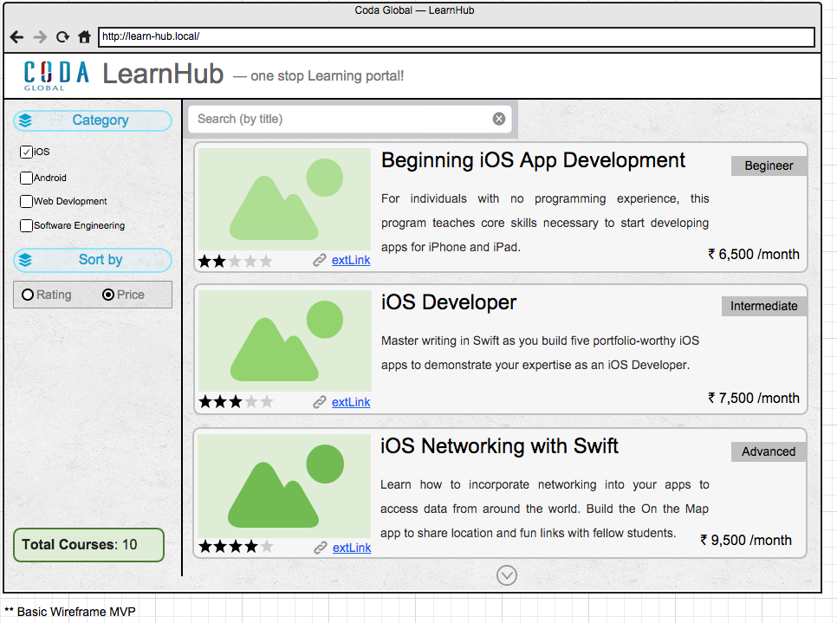

Max. Marks **100**

Top of Form

**Upload File**

**Instructions to unzip and setup project**

* *click to highlight code*



PREVIEW

[Skip](https://www.hackerearth.com/coda-global-full-stack-developer-challenge/problems/ae286b3713f5442dba23af423f82de22/)

Bottom of Form